Nama : Tarisa Dwi Septia

NIM : 205410126

1. Screnshoot program
2. 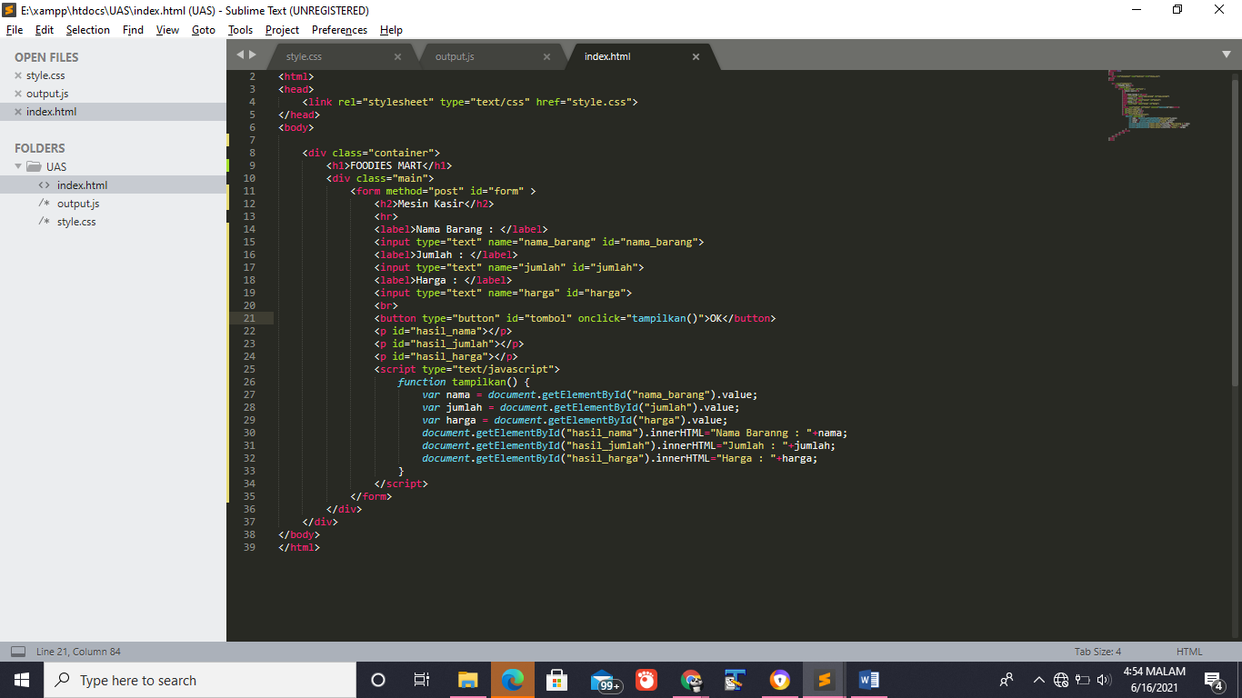Index
3. 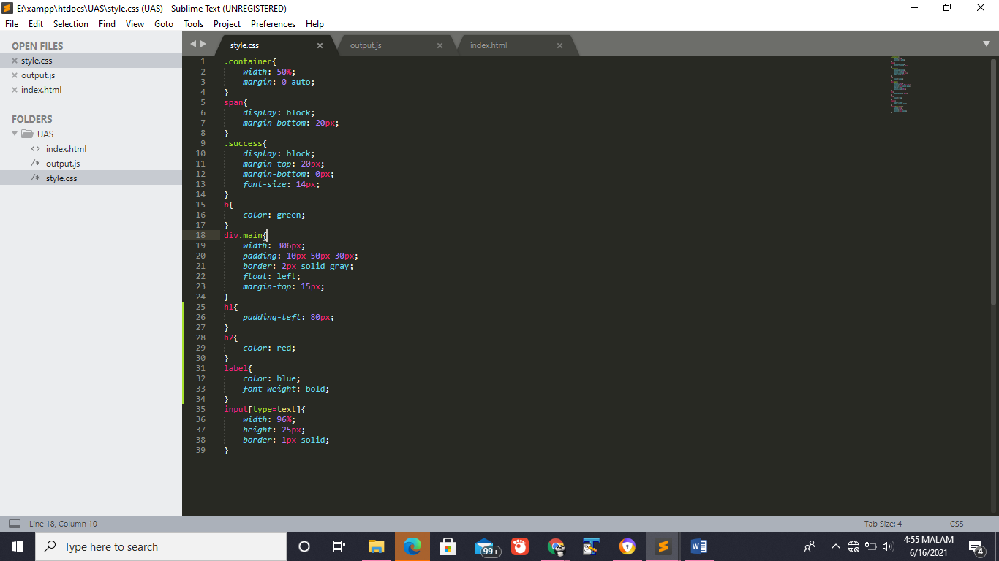Style.css
4. 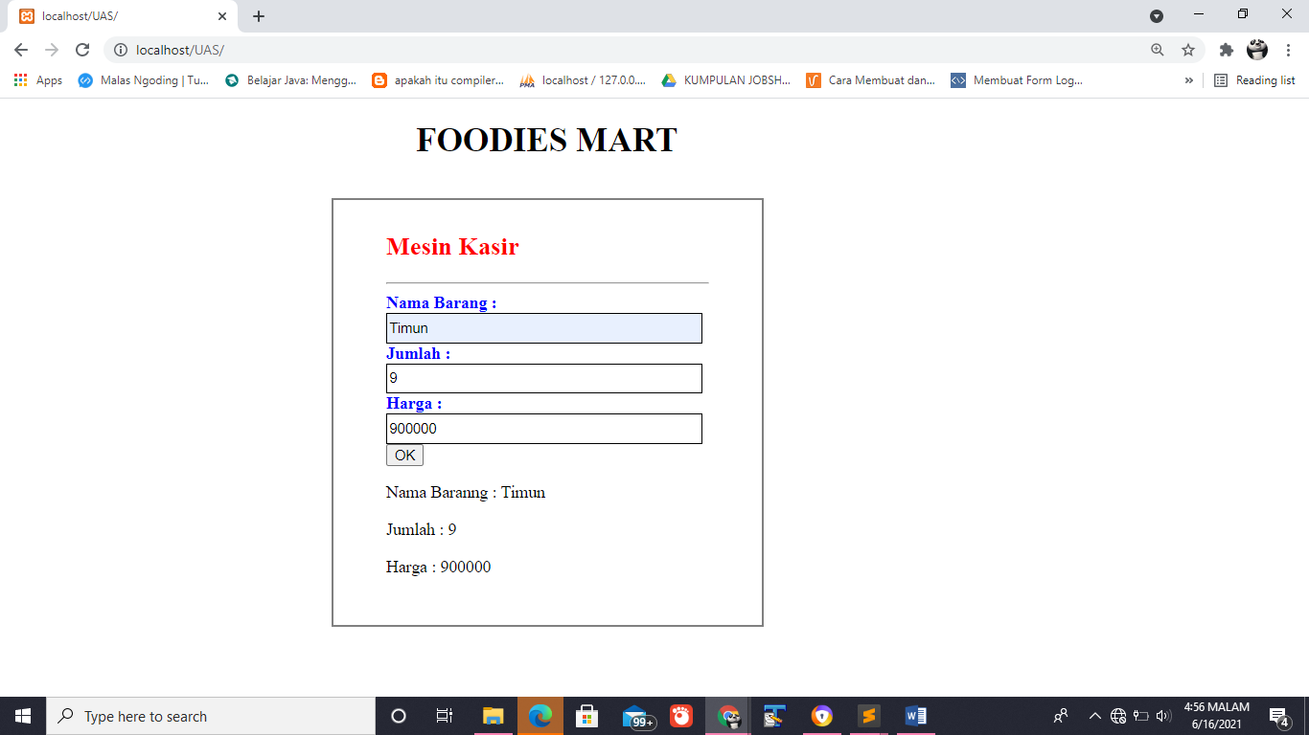Hasil Run